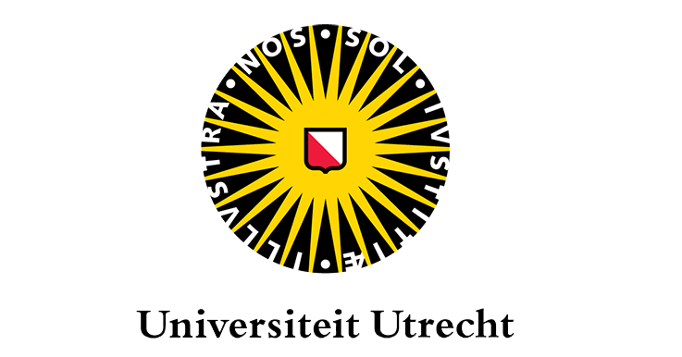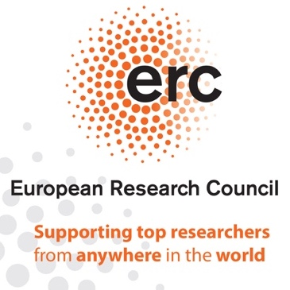

Cultures of Security in the Nineteenth Century. Transimperial Perspectives
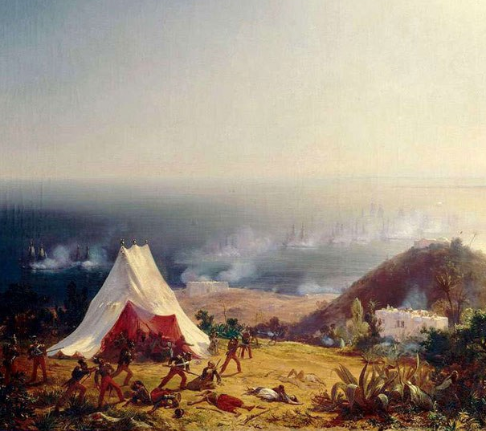
ERC SECURE final conference
Utrecht University
9 – 10 May 2019

ORGANISING TEAM

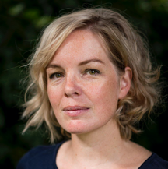
Prof. Beatrice de Graaf
Professor for the History of International Relations and Global Governance
Principal Investigator ERC SECURE
Utrecht University, The Netherlands
b.a.degraaf@uu.nl
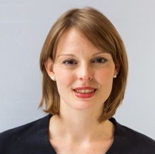
Susanne Keesman MA
Project Manager ERC SECURE
s.j.keesman@uu.nl
+31 (0)30 253 84 70
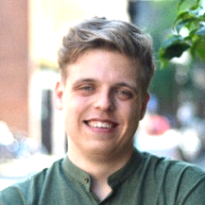

Martijn Kool BA
Student-assistant & conference support
m.kool@uu.nl
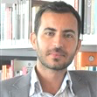
Dr. Ozan Ozavci
Assistant Professor
Postdoctoral researcher ERC SECURE
h.o.ozavci@uu.nl

CONFERENCE LOCATION

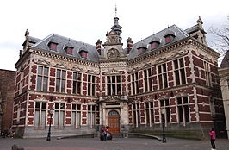
Academy Hall
Room: Kanunnikenzaal
Achter de Dom 7A
3512 JN Utrecht

PROGRAMME CONFERENCE DAY 1 | 9 MAY 2019

14:00h Registration and coffee

14:30h Introduction
Prof. Beatrice de Graaf (Utrecht University)

14:45h Panel 1: Treaties and the making of a security culture
Chair: Dr. Laurien Crump (Utrecht University)
Discussant: Dr. David Todd (King’s College, London)

Metternich’s project for a league to preserve peace in Europe. The last attempt to save the post-1815 normative approach to collective security?
- Dr. Miroslav Šedivý (University of West Bohemia)

Revisiting the Paris Treaty and the Quadruple Alliance Treaty of 20 November 1815. International revolution and transnational transformation: overcoming the restauration myth
- Prof. Beatrice de Graaf (Utrecht University)

The recorded legacy. The Paris Declaration of 1856 and its troubled precedents
- Erik de Lange MA (Utrecht University)

16:30h Break

17:00h Keynote: Junction 1815. Globalising the history of European peace and security after the Congress of Vienna
Dr. Maartje Abbenhuis (Auckland University)
Moderator: Dr. Ozan Ozavci (Utrecht University)

18:00h Drinks

19:00h Conference dinner
Stadskasteel Oudaen,
Oudegracht 99, Utrecht

We will walk to the restaurant together after the conference

PROGRAMME CONFERENCE DAY 2 | 10 MAY 2019

09:00h Coffee and tea

09:30h Panel 2: Expert security and Riparian cooperations
Chair: Dr. Rachell Gillett (Utrecht University)
Discussant: Prof. Wim van Meurs (Radboud University Nijmegen)

Transnational technocrats and the correction of an international river
- Prof. Constantin Ardeleanu (Utrecht University / University of Galați)

The CCNR in the 1840s: consolidation of an international body of expertise in a revolutionary age
- Dr. Joep Schenk (Utrecht University)

Forgetting two histories: European institutional models, empty spaces, and the failure of the 1885 Congo River Commission
- Dr. Joanne Yao (Durham University)

The “Sergeant Melanine” affair and the Congo and Niger river regimes. Rethinking the Berlin Conference and transimperial cooperation
- Dr. Angela Thompsell (College at Brockport, SUNY)

12:00h lunch

13:00h Panel 3: Empire and Extraterritoriality
Chair: Prof. Jolle Demmers (Utrecht University)
Discussant: Prof. David Schimmelpenninck van der Oye (Brock University)

A priceless grace? The Congress of Vienna, the Ottoman Empire and the politics of international law, 1814-1815
- Dr. Ozan Ozavci (Utrecht University)

Implementing treaty system in China. Focusing on the Anglo-French coalition in the nineteenth century
- Prof. Simon Yin (Hefei University of Technology)

Protecting the health of the American Empire in the “Orient”. U.S. sanitary measures in and beyond its Pacific colonies (c. 1898-1910)
- Dr. Andrea Wiegeshoff (University of Marburg)

15:00h Break

15:15h Panel 4: Police cooperation and Security
Chair: Dr. Liesbeth van de Grift (Utrecht University)
Discussant: Prof. Richard Bach Jensen (Northwestern State University)

A conservative international? Transnational policing and the origins of a European security culture after the 1848-49 revolutions
- Christos Aliprantis MA (University of Cambridge)

Founded on fear. The anti-anarchist campaign and the formation of interpersonal and formal police networks, 1890s-1914
- Wouter Klem MA (Utrecht University)

Transnational criminal law regimes, police cooperation and security in transatlantic perspective
- Prof. Karl Härter (Max-Planck-Institut für europäische Rechtsgeschichte)

17:15h Concluding Remarks

17:30h Drinks

Biographies and contact details

Maartje Abbenhuis is a historian of neutrality and internationalism, particularly in Europe in the period 1815 – 1919. She is the recipient of two Royal Society of New Zealand Marsden Grants: one in 2004 for work on the borderlands of the Netherlands in the First World War, one in 2014 for her Hague conferences project. She is in the process of co-authoring two further books for Bloomsbury: The First Age of Globalisation: An International History 1815-1918 (with Gordon Morrell, forthcoming, 2019) and Global War, Global Catastrophe. Neutrals, Belligerents and the Transformation of the First World War (with Ismee Tames, forthcoming, 2020).

Christos Aliprantis is pursuing a PhD in History at the University of Cambridge (expected to be finished in 2020). His academic point of focus is the Austrian and Prussian international secret police and intelligence operations between 1848-1870.

Constantin Ardeleanu is professor of modern Romanian history at the “The Lower Danube” University of Galaţi, where he teaches courses on 19th century Romanian history and the economic development of the Danubian and Black Sea areas during the 19th and 20th centuries. From 2015-to 2019 he was a postdoctoral research fellow within the ERC-funded project ‘Securing Europe, fighting its enemies, 1815-1914’. His monograph, The European Commission of the Danube. An Experiment in International Administration is forthcoming with Brill in 2019.

Laurien Crump is Associate Professor in the History of International Relations at Utrecht University. She is specialised in multilateral diplomacy and European security during the Cold War from both a Western and an Eastern European perspective.

Jolle Demmers is Professor in Conflict Studies at the History of International Relations section at Utrecht University. Under the heading of The Intimacies of Remote Warfare, she is currently engaged in research projects on the spatial and temporal reconfiguration of warfare and its blowback effects.

Rachell Gillett is Assistant Professor in Cultural History at Utrecht University. Her research focuses on race in France, popular culture, and on the Black Atlantic from a French perspective. Her current book, under contract with OUP, is entitled Begin the Beguine: Race and Popular Music in Interwar Paris.

Beatrice de Graaf is professor of History of International Relations & Global Governance at Utrecht University, and chairs the section History of International Relations. Her research focuses on history of national security in the West (19th-21st century), counterterrorism and political violence, securitisation and international relations and historical research on the development of security thinking. She received numerous grants and awards for her work, amongst which an ERC consolidator grant (€1.9m) and the NWO Stevin prize (€2m), the highest distinction in Dutch academia. De Graaf is member of the Royal Netherlands Academy of Arts and Sciences and of the European Council on Foreign Relations.

Liesbeth van de Grift is Assistant Professor in the History of International Relations at Utrecht University. She specializes in the international history of rural and environmental governance in the twentieth century. She received an NWO VIDI research grant in 2018 (€700k)

Karl Härter is research group leader and senior researcher at the Max Planck Institute for European Legal History, Frankfurt am Main, and professor for Early Modern and Modern History, University of Darmstadt. His research interests concern legal-, political- and constitutional history; current projects focus on transnational criminal law and security as well as on political crime, legal responses and popular media in Early Modern and Modern Europe. Recent publications include Strafrechts- und Kriminalitätsgeschichte der Frühen Neuzeit (De Gruyter 2018) and the edited volume Transnationalisation of Criminal Law in the Nineteenth and Twentieth Century (Klostermann 2019).

Richard Bach Jensen is Professor Em. of History at the Louisiana Scholars’ College at Northwestern State University. He is a recognized authority on the repression of anarchist terrorism and has published widely in the field. Jensen is the author of The battle against Anarchist Terrorism: An International History, 1878-1934 (Cambridge University Press 2015).

Susanne Keesman is project manager of a number of research projects, amongst which the ERC-funded research project ‘Securing Europe, Fighting its enemies, 1815-1914’. She is manager of the interdisciplinary research hub Security in Open Societies and was managing editor of the recently published edited volume Securing Europe After Napoleon (Cambridge University Press 2019).

Wouter Klem is a PhD candidate within the research project ‘Securing Europe, fighting its enemies 1815-1914’, granted by the European Research Council. Within this Project, he studies the transnational security regime that emerged as the European campaign against anarchist terrorism in the period 1881-1914. This campaign resulted in transnational networks of police and judicial authorities, secretive protocols and international conferences.

Erik de Lange is a PhD candidate at Utrecht University, working within the ERC-funded research project ‘Securing Europe, Fighting its Enemies, 1815-1914’. He is currently finishing his dissertation, which is tentatively titled Menacing tides. Security, piracy and empire in the nineteenth-century Mediterranean. He has contributed to various edited volumes, including the recently publish Securing Europe after Napoleon. Erik is also the chief editor of the ERC project’s ‘Utrecht School for Historicising Security Blog’.

Wim van Meurs is professor of European political history at the Radboud University Nijmegen. His research revolves around theree topics: the history of European integration; peasant parties and political modernisation; the politics of environmental governance. In 2018 he published the co-authored handbook The Unfinished History of European Integration (Amsterdam University Press).

Ozan Ozavci is assistant professor at Utrecht University, and postdoctoral researcher within the ERC-funded project ‘Securing Europe, Fighting its enemies, 1815-1914’. Having published his first book on the history of liberalism in the late Russian and Ottoman empires and modern Turkey, he is currently finalising a monograph titled Dangerous Gifts: Imperialism, Security, and Civil Wars in the Levant, 1798-1864 (Oxford University Press, forthcoming 2020).

Joep Schenk is a postdoctoral researcher within the ERC-project 'Securing Europe, fighting its enemies 1815-1914'. The central theme in his research is the study of the tensions between transnational agency and national political structures. His monograph The Rhine and European Security in the Long Nineteenth Century: Making Life from Frontlines is forthcoming with Routledge in 2019.

David Schimmelpenninck van der Oye is professor of Russian History at Brock University in Ontario, Canada. He teaches courses in Russian and Inner Asian history. His research interests focus on Imperial Russian intellectual, cultural and diplomatic topics.

Miroslav Šedivý is senior lecturer at the Department of Historical Sciences at the University of West Bohemia in Pilsen. He is the author of Metternich, the Great Powers and the Eastern Question (University of West Bohemia Press 2013) and holds a PhD from Charles University, Prague.

Angela Thompsell is associate professor of History at the College at Brockport, State University of New York. She is specialized in British imperialism in Africa; economic and cultural impact of big-game hunting; history of environmentalism, science, gender, and empire.

David Todd is a senior lecturer in world history at King’s College London. He is the author of Free Trade and its Enemies in France (Cambridge, 2015) on intellectual discussions of global economic integration in nineteenth-century France and is now completing a book, due to be published by Princeton University Press, on the legal and economic aspects of French informal imperialism between 1815 and 1880.

Andrea Wiegeshoff is assistant professor at the University of Marburg. She received her PhD in modern history from the University of Marburg in 2011 and is currently engaged in her second book project. From 2006 to 2014, she worked as a project coordinator and research assistant of the Independent Historians Commission to clear up the history of the German Foreign Office in the National Socialist Period and in the Federal Republic and as a policy advisor for the German Council of Science and Humanities.

Joanne (Yuan) Yao is assistant professor in international relations at Durham University. Her current work approaches environmental cooperation from a historical perspective, by analysing how and why the first international organizations were established in the 19th century to manage a contested transboundary issue—the international river.

Simon (Shuxi) Yin is professor at Hefei University of Technology and chair of the department of global studies. He obtained his MA degree from Harvard University and his PhD from the University of Tübingen.

Name | Affiliation | E-mail
Dr. Maartje Abbenhuis | University of Auckland | m.abbenhuis@auckland.ac.nz
Christos Aliprantis MA | University of Cambridge | ca474@cam.ac.uk
Prof. Constantin Ardeleanu | University of Galati / Utrecht University | c.ardeleanu@uu.nl
Yannick Balk MA | Utrecht University | y.s.a.balk@uu.nl
Dr. Laurien Crump | Utrecht University | l.c.crump@uu.nl
Prof. Jolle Demmers | Utrecht University | j.demmers@uu.nl
Dr. Rachel Gillett | Utrecht University | r.a.gillett@uu.nl
Prof. Beatrice de Graaf | Utrecht University | b.a.degraaf@uu.nl
Dr. Liesbeth van de Grift | Utrecht University | l.vandegrift@uu.nl
Prof. Karl Härter | Max Planck Institute for European Legal History | haerter@rg.mpg.de
Prof. Richard Bach Jensen | Northwestern State Universty | jensenr@nsula.edu
Paul Kardoulakis MA | University of Antwerp | p.kardoulakis@uu.nl
Susanne Keesman MA | Utrecht University | s.j.keesman@uu.nl
Wouter Klem MA | Utrecht University | w.m.klem@uu.nl
Martijn Kool BA | Utrecht University | m.kool@uu.nl
Erik de Lange MA | Utrecht University | e.delange@uu.nl
Prof. Wim van Meurs | Radboud University Nijmegen | w.v.meurs@let.ru.nl
Dr. Ozan Ozavci | Utrecht University | h.o.ozavci@uu.nl
Dr. Joep Schenk | Utrecht University | j.schenk@uu.nl
Prof. David Schimmelpenninck van der Oye | Brock University, Ontario | dschimme@brocku.ca
Dr. Miroslav Šedivý | University of West Bohemia | sedivym@khv.zcu.cz
Dr. Angela Thompsell | College at Brockport, SUNY | athompse@brockport.edu
Dr. David Todd | King’s College, London | David.todd@kcl.ac.uk
Dr. Andrea Wiegeshoff | University of Marburg | Andrea.wiegeshoff@uni-marburg.de
Dr. Joanne (Yuan) Yao | Durham University | Yuan.yao2@durham.ac.uk
Dr. Feroze Yasamee | Manchester University | fakyasamee@gmail.com
Prof. Simon (Shuxi) Yin | Hefei University of Technology | yin.shuxi@gmail.com

